IMAGE PROMPT 1
{
"subject": "A classical Bharatanatyam dancer in an expressive Aramandi mid-pose, adorned in vibrant silk costume, temple jewellery, and intricate ghungroos",
"setting": "An ancient stone-pillared mandapam of a South Indian temple with rich heritage carvings",
"visual_style": "Cinematic portrait photography with sharp focus on the dancer's expressive mudras and costume details",
"colour_palette": "Vibrant temple red, peacock green, rich gold zari, and sandstone brown",
"lighting": "Dramatic warm golden hour sunlight streaming through the stone pillars, creating a halo effect",
"mood": "Graceful, dynamic, devotional, and powerful",
"composition": "Full-body wide shot, centered, emphasizing symmetry and sculptural posture",
"aspect_ratio": "9:16"
}

Output:
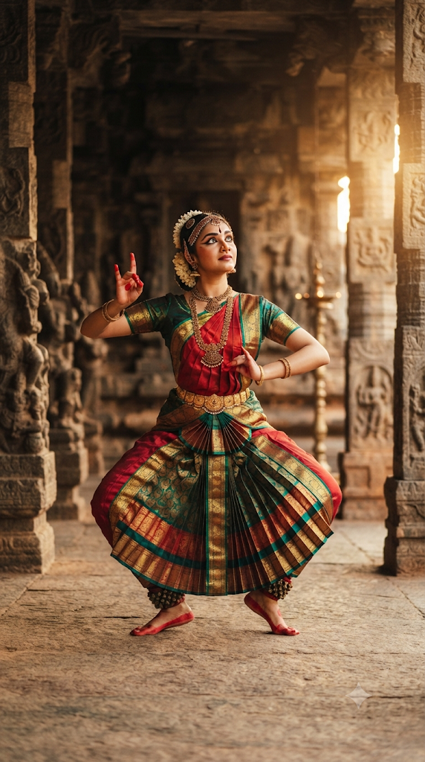
IMAGE PROMPT 2
{
"subject": "The three specific children participating in a Ganesh Chaturthi pooja: an older girl with dark hair wearing a deep purple embroidered dress, a toddler girl with a top-knot wearing a peach and purple pattu pavada with hands in a prayer pose, and a smiling young boy wearing a cream shirt and a traditional veshti, all gathered around a beautifully decorated clay Ganesha idol",
"setting": "A traditional Tamil Nadu home living room adorned with a fresh mango leaf thoranam, glowing brass kuthuvilaku lamps, and vibrant marigold flower decorations",
"visual_style": "Photorealistic cultural portrait photography, with sharp focus on traditional attire textures and festive elements",
"colour_palette": "Festive marigold yellow, temple gold, deep purple, peach, and warm earthy tones",
"lighting": "Warm, soft indoor glow from traditional oil lamps casting gentle highlights on the children and the idol",
"mood": "Devotional, joyous, warm, and celebratory",
"composition": "Medium full shot, eye-level angle framing the three children together around the festive setup",
"aspect_ratio": "16:9"
}

OUTPUT: 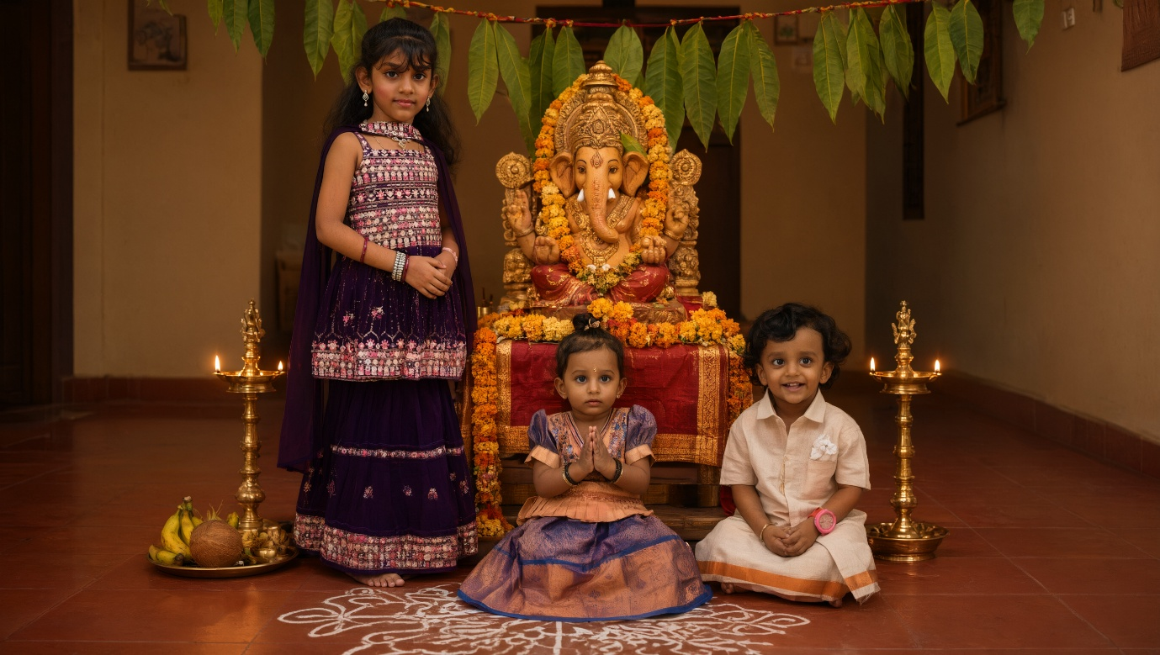
IMAGE PROMPT 3
{
"subject": "Authentic south Indian filter coffee being poured in a traditional brass davara and tumbler set, creating a rich froth layer",
"setting": "A polished wooden table in a heritage home with a banana leaf accent in the background",
"visual_style": "Commercial food photography, hyper-detailed steam and liquid texture",
"colour_palette": "Rich browns, warm brass golds, deep greens, and amber tones",
"lighting": "Warm side lighting highlighting the steam rising and the metallic sheen of the brass",
"mood": "Inviting, aromatic, and comforting",
"composition": "Medium close-up action shot capturing the milk stretch from a height",
"aspect_ratio": "1:1"
}

OUTPUT: 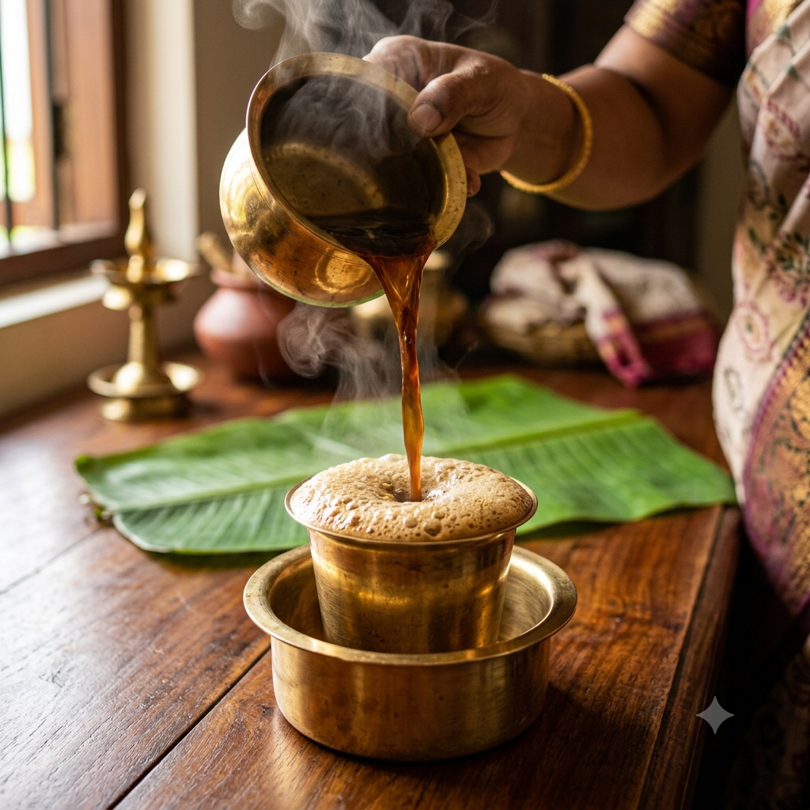

VIDEO PROMPT
{
"subject": "The three children—an older girl in a deep purple embroidered dress, a toddler girl with a top-knot in a peach and purple pattu pavada, and a young boy in a cream shirt and veshti—joyfully participating in a Ganesh Chaturthi prayer ritual",
"setting": "A traditional Tamil Nadu home living room decorated with a fresh mango leaf thoranam and glowing brass kuthuvilaku lamps[cite: 1]",
"visual_style": "Cinematic and heartwarming storytelling video with crisp detail",
"colour_palette": "Festive marigold yellow, temple gold, deep purple, peach, and warm earthy tones",
"lighting": "Warm, soft indoor glow from traditional oil lamps casting gentle highlights on the children",
"mood": "Devotional, festive, joyous, and magical",
"composition": "Medium full shot framing the three children together around the decorated clay Ganesha idol",
"aspect_ratio": "16:9",
"motion": "Continuous gentle camera pan moving from the glowing oil lamps to capture the smiling faces of the three children[cite: 1]",
"duration": "10 seconds[cite: 1]"
}
OUTPUT

